**DEPARTMENT OF MINING ENGINEERING (NITK)**



ASSIGNMENT SUBMISSION ON

**Stress Distribution Around Underground Openings**

**Submitted By**

*Dwaipayan Munshi*

(181MN010)

**Submitted To**

*Dr Karra Ram Chandar*

[ASSIGNMENT 1a (Stress Distribution Around Single Openings)](https://drive.google.com/file/d/11VWAp10WRVoykqmnUzcpvm_G3o7ZytFL/view?usp=sharing)

[ASSIGNMENT 1b (Stress Distribution Around Multiple Openings)](https://drive.google.com/file/d/1OQbf79KXXmJGDSkYisizdiwG1qNnENNX/view?usp=sharing)

[ASSIGNMENT 2 (Greenspan Method)](https://drive.google.com/file/d/1YCtEykximOSwCI8IHZHKdnP4lpP3UGkQ/view?usp=sharing)

*Instructions*

**Download HTML File**

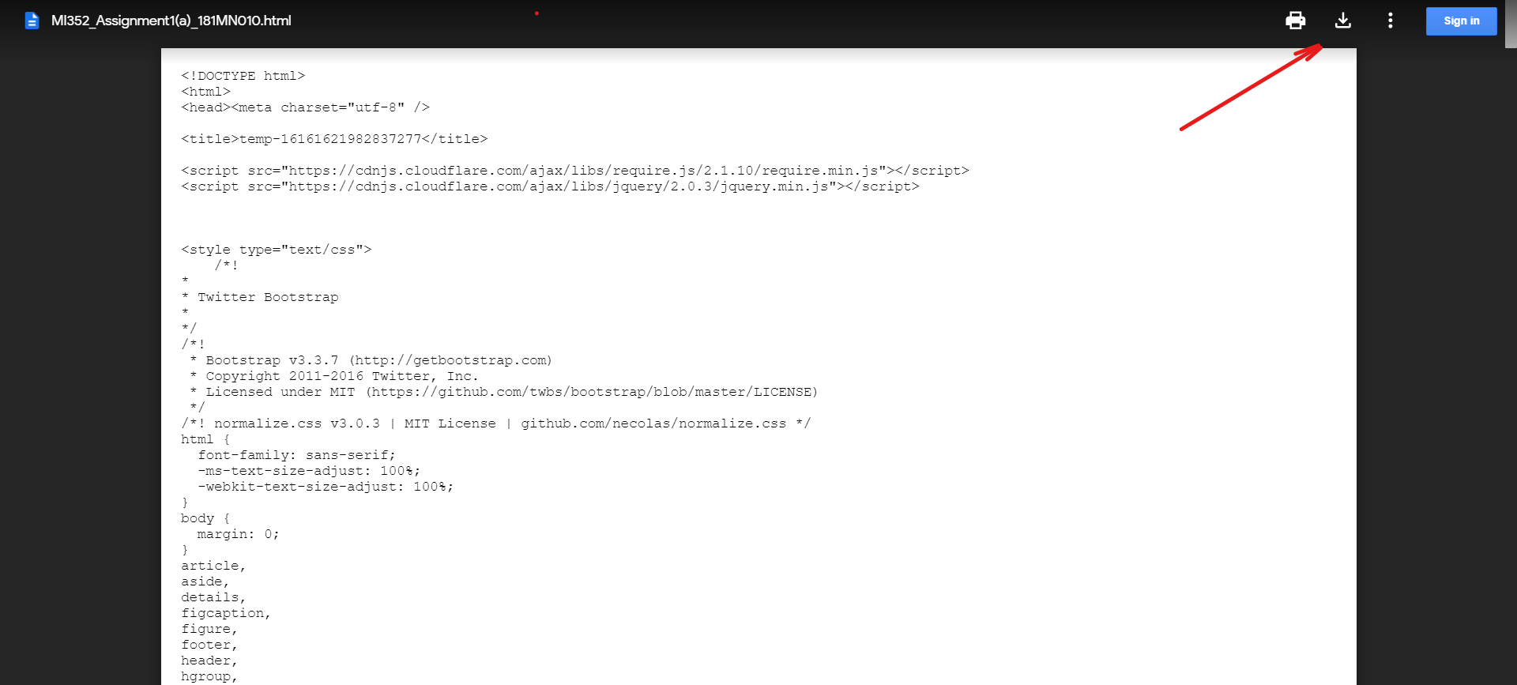

**Open HTML File With Chrome**

(Couldn’t Upload Directly due to File Restrictions)